History of English

-A brief introduction-

Presented

By

P.V.Krishna Rao

Lecturer in English, P.R.Government College (A),

Kakinada

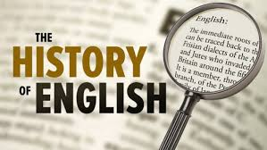
Why should one take part in a seminar on The History of English?

- In general, to find out about where English came from, how it developed and how it came to have its present form. This also includes learning about the relationship of English to its Germanic neighbors and to other European languages.

- Specifically, to learn more about the different linguistic levels of the English language in their historical dimensions. This includes the following areas.

  - How was the spelling of English devised, what principles governed it originally? This helps in trying to grasp the inconsistencies which have arisen in the five centuries since the orthography was developed and so helps one to remember spellings easier.

  - How did the current pronunciation norm (Received Pronunciation) develop in England and how does it relate to vernacular forms of English, such as Cockney (the city dialect of London)?

  - Why is the grammar of English the way it is? Why are there few endings compared to German and why is the syntax (use of prepositions or verbal forms) relatively difficult.

  - How did the vocabulary of English gain its present form? Why is there a stylistic division in the lexicon of the language with different layers corresponding to different degrees of formality?

- How have different varieties of English arisen outside of England? What were the pathways along overseas forms of English developed in the colonial period?

- To learn about the techniques of historical linguistics, how does one reconstruct previous stages of a language, how does one compare languages, what assumptions are legitimate about diachronic stages of a language.

- To understand more about the phenomenon of language change and ultimately to gain insights into the structure of language in general and how speakers use it.

Old English

Historical relationship of English and German
- Techniques of historical linguistics
- The coming of the English, divisions of Old English
- The structure of Old English
- Literature and society in the Old English period
- The Old English epic Beowulf

The Scandinavian invasions and effects
- The Anglo-Saxon chronicle

Middle English

- The Anglo-Norman period, transition of Old to Middle English
- French influence on Middle English
- Spelling practice in Middle English
- The Great Vowel Shift and English pronunciation
- Literature during the Middle English period
- Religious writings in the Middle English period
- Mythology and literature in the Middle English period
- Private writing (family letters) in the Middle English period
- The age of Chaucer; Chaucer’s major works

Early Modern Period

- The introduction of printing and English orthography
- English at the time of Shakespeare
- The Inkhorn Controversy and ‘hard words’
- Shakespeare’s use of English
- The rise of the dictionary
- Views on English in the Augustan Age
- Grammatical prescriptivism in the 18thcentury
- The emergence of standard pronunciation

Views of Language Change

- Models of language change and the history of English
- Documents for English and reconstruction techniques
- Relative chronology in the history of English
- Language contact and the history of English
- Typological change and the history of English
- Grammaticalisation and the history of English

The background to English

This seminar will be concerned with the development of the English language from the earliest attestations and also considered the background to the language before the settlement of England by Germanic tribes.

There are three main divisions in the history of English and these were reflected in the presentations which were given during the term:
Old English (450 to1066)
Middle English (1066 to 1500) Early Modern English (1500onwards)

The origins of English

Themes in this period

- The Indo-European language family
- The Germanic languages, major sound changes
- Historical relationship of English to German
- The techniques of historical language study Internal reconstruction
Comparative linguistics

External history
Old English(450-1066)

  - The coming of the Germanic tribes to England (c450)
  - The Christianization of England (c600)
  - The Scandinavian invasions (c800)

Literature
  - Epic literature: Beowulf (c 800, manuscript from c1000)
  - Minor poetry (600onwards)
  - The Anglo-Saxon Chronicle (8th century on wards)

Structure of language
  - Sound system
  - Grammatical system
  - Vocabulary (Latin borrowings; Scandinavian borrowings)

Middle English(1100-1500)
External history

  - The coming of the Anglo-Normans to England(1066)
  - The break with France(1204)
  - The introduction of printing(1476)

Literature
  - Continuations of the Anglo-Saxon Chronicle
  - Alliterative verse revival (14thcentury)
  - Geoffrey Chaucer(1340-1399)

Structure of language
  - Sound system
  - Grammatical system
  - Vocabulary (Anglo-Norman and Central borrowings)

Early Modern English(1500onwards)
External history

  - The Renaissance in England (16th century and later)
  - Development of overseas colonies (17th century and later)
  - Transportation of English to the Caribbean, North American
  - Civil war in England and later Restoration
  - 18th century: Transportation of English to overseas locations
  - The development of prescriptive attitudes in 18th and 19th century England
Literature

  - 16th century writers
  - The age of Shakespeare
  - Restoration writers(drama)
  - The Augustan age
  - The rise of the novel (18thcentury)
  - 19th century poetry and prose
  - Journalistic literature from pamphlets to newspapers

Early Modern English(continued)

Structure of language
- Sound system
The Great Vowel Shift
- Grammatical system
- Vocabulary
- The Inkhorn Controversy
- Classical borrowings, Latin and Greek
- Later French loans, borrowings from other languages

Groups of Indo-European languages

Indo-European Main Subgroups
Hellenic Italic Albanian

Baulk
Celtic

Slavic Germanic Hittite

Germanic
Indo-Iranian Tocharian

North Icelandic, Swedish, Norwegian (Bokmâl&Nynorsk),Danish, Faroese

Pez/ English, German, Low German, Frisian, Dutch, Flemish, Ahikaans, Yiddish

Emi Go%c

Main divisions of Germanic

OLDESTSTAGE

North Germanic
Runes (3/4c) Old Norse (13c)

East Germanic
Gothic (4c)
PRESENT-DAY LANGUAGES

Icelandic, Faroese, Swedish,
Norwegian (Bokmal & Nynorsk) and Danish

(none)

Old High German(8c) High German (Yiddish) Old English(7c) English
Old Saxon(8c) Low German
Old Frisian(14c) Frisian (North and West) Old Low Franconia(12c) Dutch, Flemish, Afrikaans

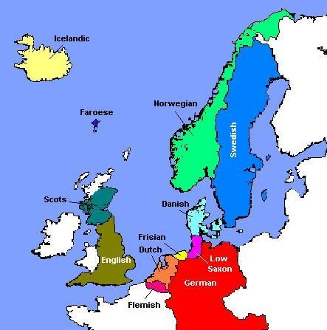

The Germanic languages today

Periods in the development of English

It is common to divide the history of English into three periods and old, a middle and an early modern one. The justification for this is partly external and partly internal. The Old English period begins in the middle of the 5th century with the coming of Germanic tribes to settle in England. The Middle English period begins with the conquest of England by Normans after their success in the Battle of Hastings in 1066, the end of this period is marked by the introduction of printing by William Caxton in 1476. The early modern period begins with the 16th century and is characterized by an expansion in vocabulary by borrowing from classical languages, by the gradual conclusion of the Great Vowel Shift (see below) and by the regularization of English grammar after the demise of the language's former inflectional morphology.

Old English
English has been spoken in England since around 450. To be more precise a set of varieties of West Germanic have been spoken. After the Anglo- Saxon invasion no-one had an awareness of England as such let alone of English. With the establishment of the West Saxon kingdom in later centuries and with the court which formed the pivot point of this kingdom a first inkling of the idea of English developed. With the invasion of England by the Danes (after 800) it became more clear that the Germanic tribes in England were separate from their fellows on the Continent and in Scandinavia. Among the different groupings in England in the Old English period different dialects (that is purely geographical variants) are recognizable: Northumbrian in the north, Anglican in the middle and West- Saxon in the south. Due to the political significance of West-Saxon in the late Old English period (after the 9th century) the written form of this dialect developed into something like a standard. Note that at this time it was Winchester and not London which was the political centre of the country. The term used for the West Saxon 'standard' is koiné which derives from Greek and means a common dialect, that is a variety which was used in monasteries in parts of England outside of West Saxony for the purpose of writing.

The dialects of Old English
It is common to divide England into four dialect areas for the Old English period. First of all note that by England that part of mainland Britain is meant which does not include Scotland, Wales and Cornwall. These three areas were Celtic from the time of the arrival of the Celts some number of centuries BC and remained so well into the Middle English period.
The dialect areas of England can be traced back quite clearly to the Germanic tribes which came and settled in Britain from the middle of the 5th century onwards. There were basically three tribal groups among the earlier settlers in England: the Angles, the Saxons and the Jutes. The Angles came from the area of Angela (roughly the Schleswig-Holstein of today), the Saxons from the area of east and central Lower Saxony and the Jutes from the Jutland peninsula which forms west Denmark today.
Of these three groups the most important are the Saxons as they established themselves as the politically dominant force in the Old English period. A number of factors contributed to this not least the strong position of the West Saxon kings, chief among these being Alfred (late 9th century). The West Saxon dialect was also strongest in the scriptoria (i.e. those places where manuscripts were copied and/or written originally) so that for written communication West Saxon was the natural choice.

The dialects of Old English(continued)

A variety of documents have nonetheless been handed down in the language of the remaining areas. Notably from Northumbria a number of documents are extant which offer us a fairly clear picture of this dialect area. At this point one should also note that the central and northern part of England is linguistically fairly homogeneous in the Old English period and is termed Anglia. To differentiate sections within this area one speaks of Mercia which is the central region and Northumbria which is the northern part (i.e. north of the river Humber).
A few documents are available to us in the dialect of Kent
(notably a set of sermons). This offers us a brief glimpse at the characteristics of this dialect which in the Middle English period was of considerable significance. Notable in Kentish is the fact that Old English /y:/ was pronounced /e:/ thus giving us words like evil in Modern English where one would expect something like ivil.

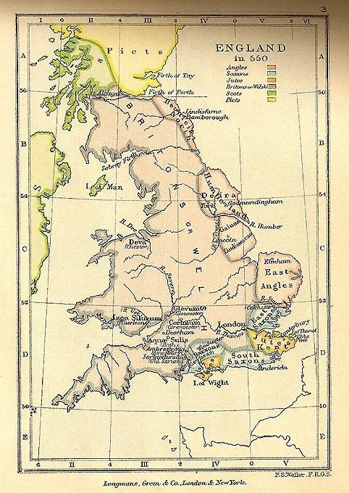

England at the time of the Germanic invasions

North Sea

Jutes

N.rthmb.: Angles

Saxons
Angles

Frisianislands

dialect area northofThames)
Angles

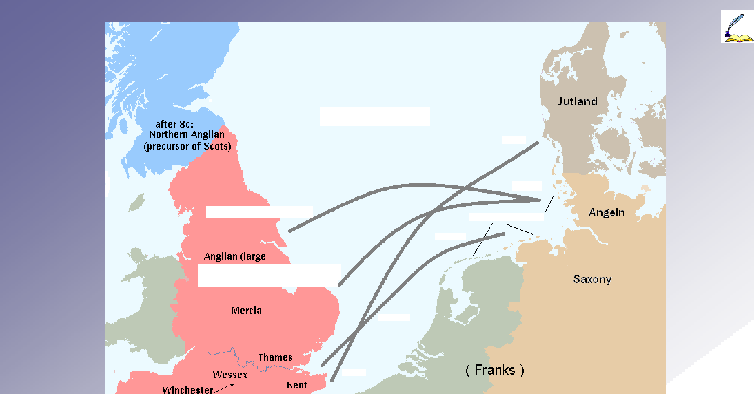

Saxons

Jutes

Raymond HickeyDecember 2005

Routestahen across theNorthSeabyGermanictribesinthe5c.TheJutescamefromJutlandand settledinKent.TheSaxonscamefromtheareaofpresent-day(Lower)Saxonyandsettledlargely southoftheRiverThames.TheAnglescamefromthelowerpartofthetheJutlandpeninsulawhich is now Schleswig Holstein in Germany and settled in central and northern England.
Thelinesintheabovemapareyeryapproximate.ManyofthesettlersmayhayecrossedtheNorth Seafromtheareaofpresent-dayBelgiumasthiswouldhaveinvolvedtheshortestseajourney.

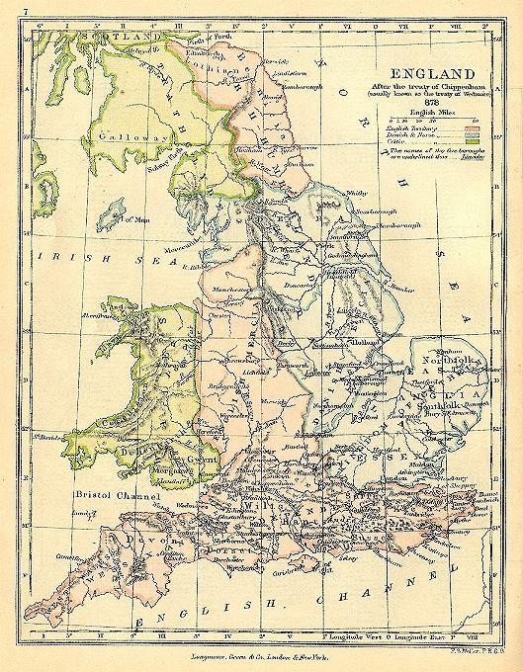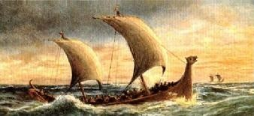

England during the Viking

period

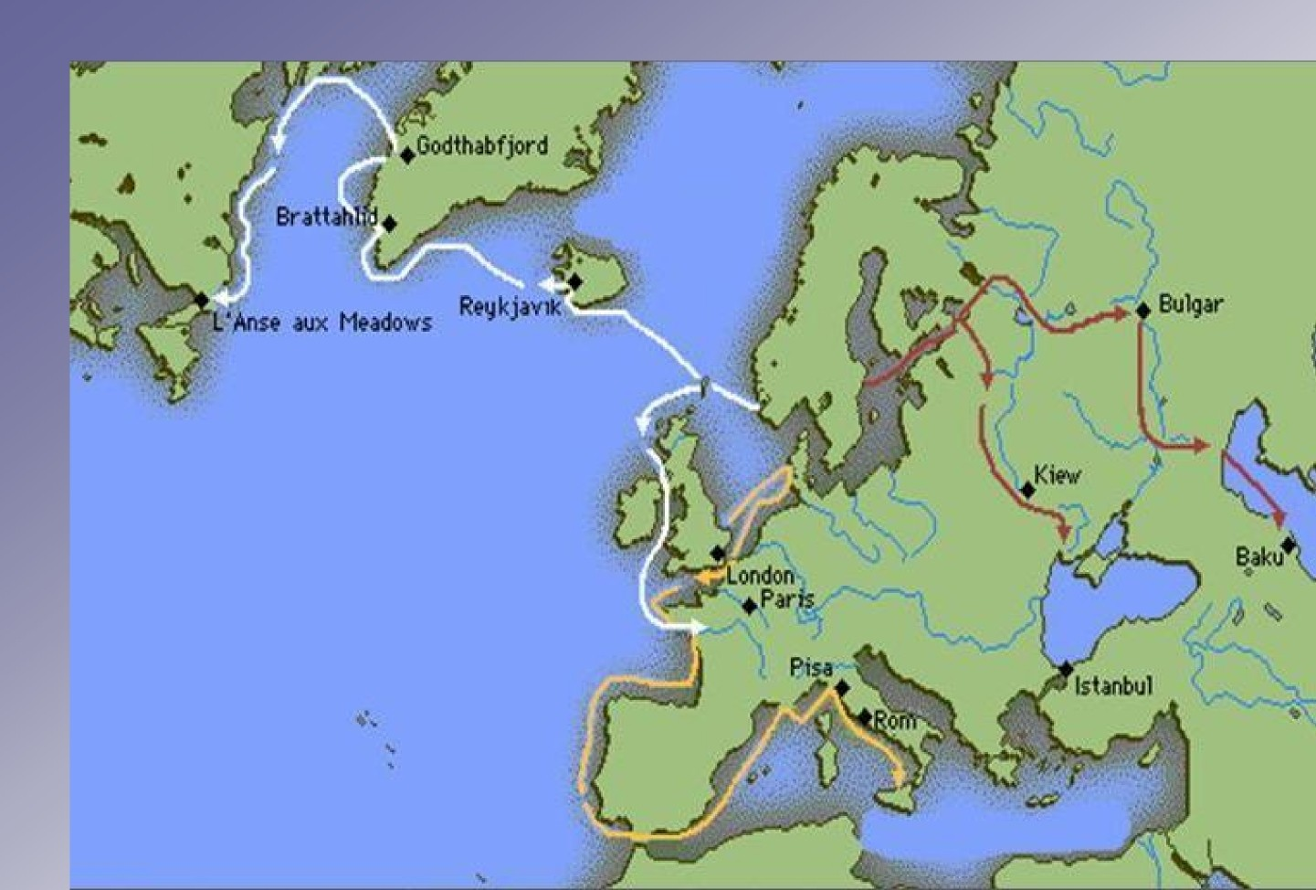

MainVikingexpansionroutesfromthe8thtothe11thcenturies

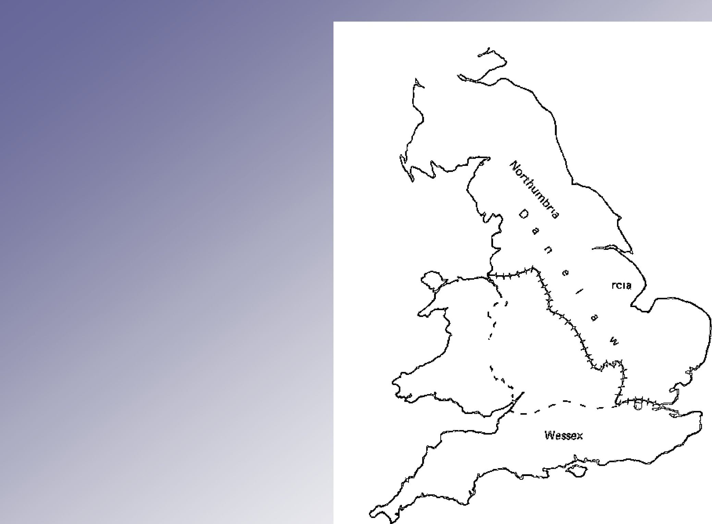The Dane law

During the Viking period the territory of England was divided into a Scandinavian and a West Saxon sphere of influence. The former was known as the Dane law. In this region the greatest influence of the Vikings on the Old English was felt. Many

Danish

Ang)ia

Scandinavian places names are attested in the north of England.
London

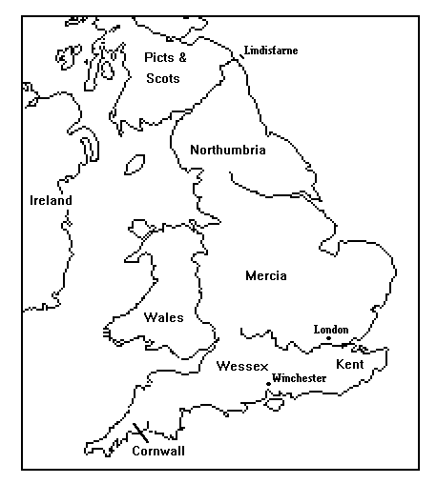

Old Englishdialectareas

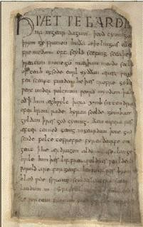

Open page of Beowulf manuscript

On the right you see the opening lines of Beowulf. Click on the speaker symbols below to hear sections of the text spoken in what we assume was the West Saxon pronunciation of Old English.

First section Second section Third section

in ho-rsOurs Direx' w.’

unE tohemoazA ”ofth”o rghbotsrc

‹u airsx «›c
wos: fame<L

ren ri w«tdety ”pad-g <•f S<$dd"s h•eirDanish

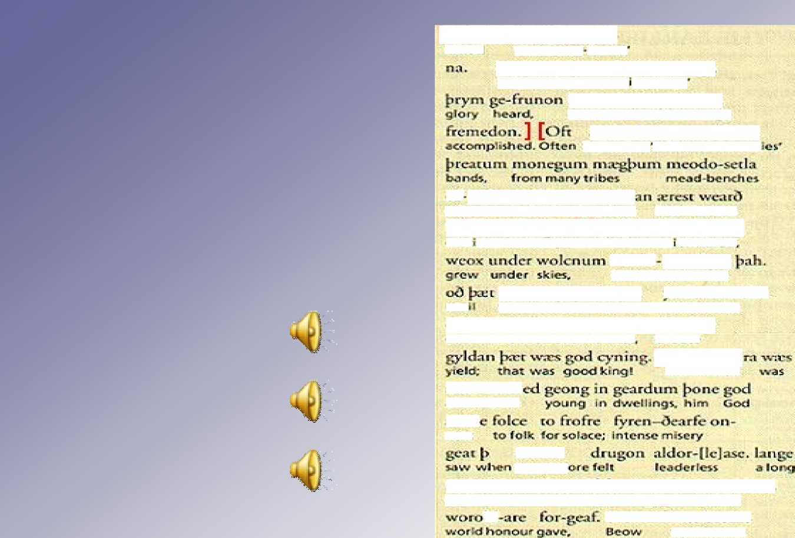

The Our Father in Old English

Fæder ure þu þe eart on heofonum;
Si þin nama gehalgod to becume þin rice gewurþe ðin willa
on eorðan swa swa on heofonum.
urne gedæghwamlican hlaf syle us todæg and forgyf us ure gyltas
swa swa we forgyfað urum gyltendum and ne gelæd þu us on costnunge
ac alys us of yfele soþlice.

Click to listen:

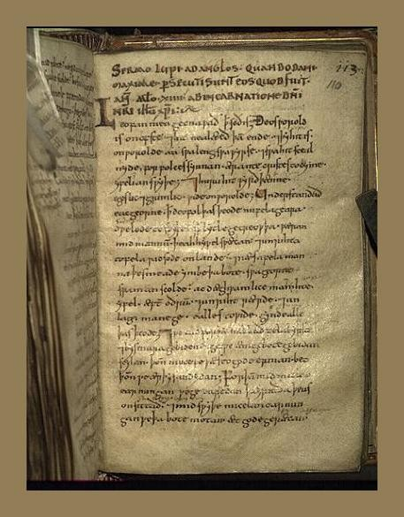

Wolfstan´sSermon to the English

Middle English

After the invasion of England by the Normans in 1066, the West Saxon 'standard', which was waning anyway due to natural language change, was dealt a death blow. Norman French became the language of the English court and clergy. English sank to the level of a patois (an unwritten dialect). With the loss of England for the French in 1204 English gradually emerged as a literary language again. For the development of the later standard it is important to note (1) that it was London which was now the centre of the country and (2) that printing was introduced into England in the late 15th century (1476 by Caxton). This latter fact contributed more than any single factor to the standardization of English. It is obvious that for the production of printing fonts a standard form of the language must be agreed upon.
This applied above all to spelling, an area of English which was quite
chaotic in the pre-printing days of the Middle English period.

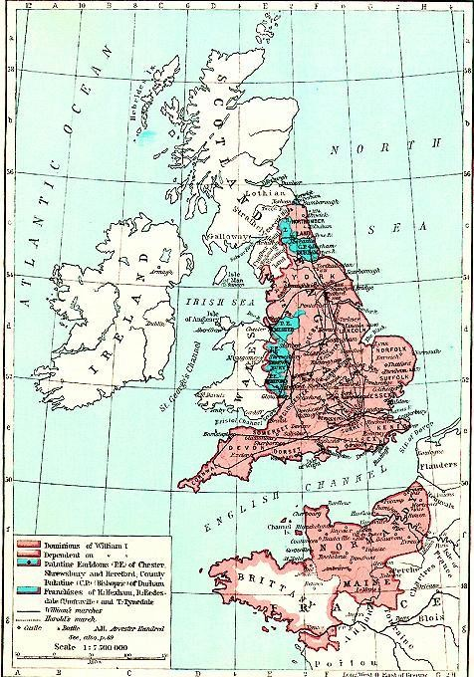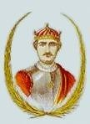

England at the time of the Norman Invasion

William the Conqueror

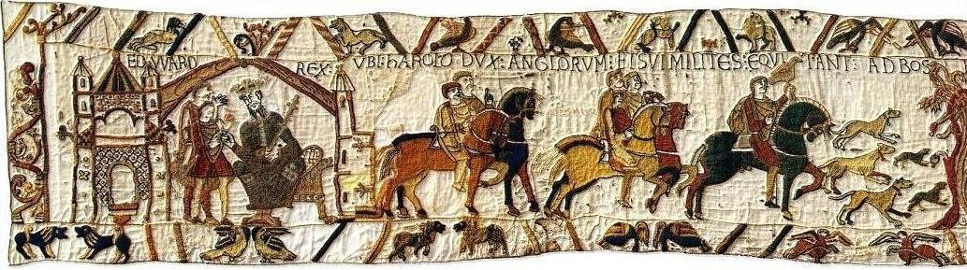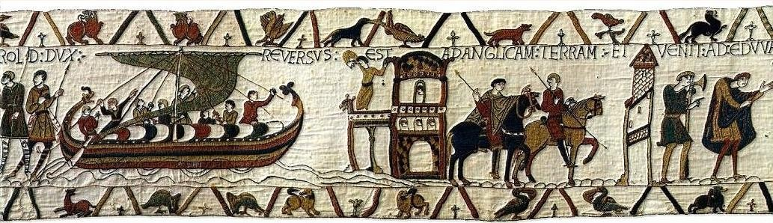
The Bayeux Tapestry depicting scene from the Norman Invasion, 1

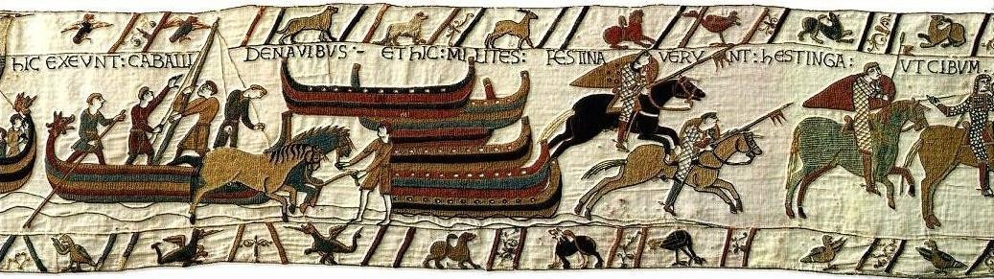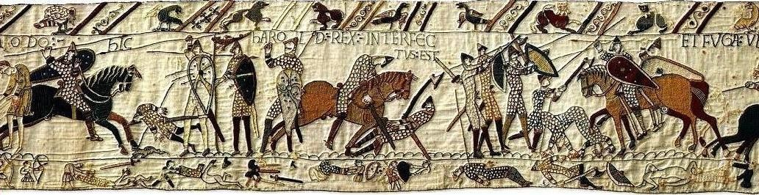
The Bayeux Tapestry depicting scene from the Norman Invasion, 2

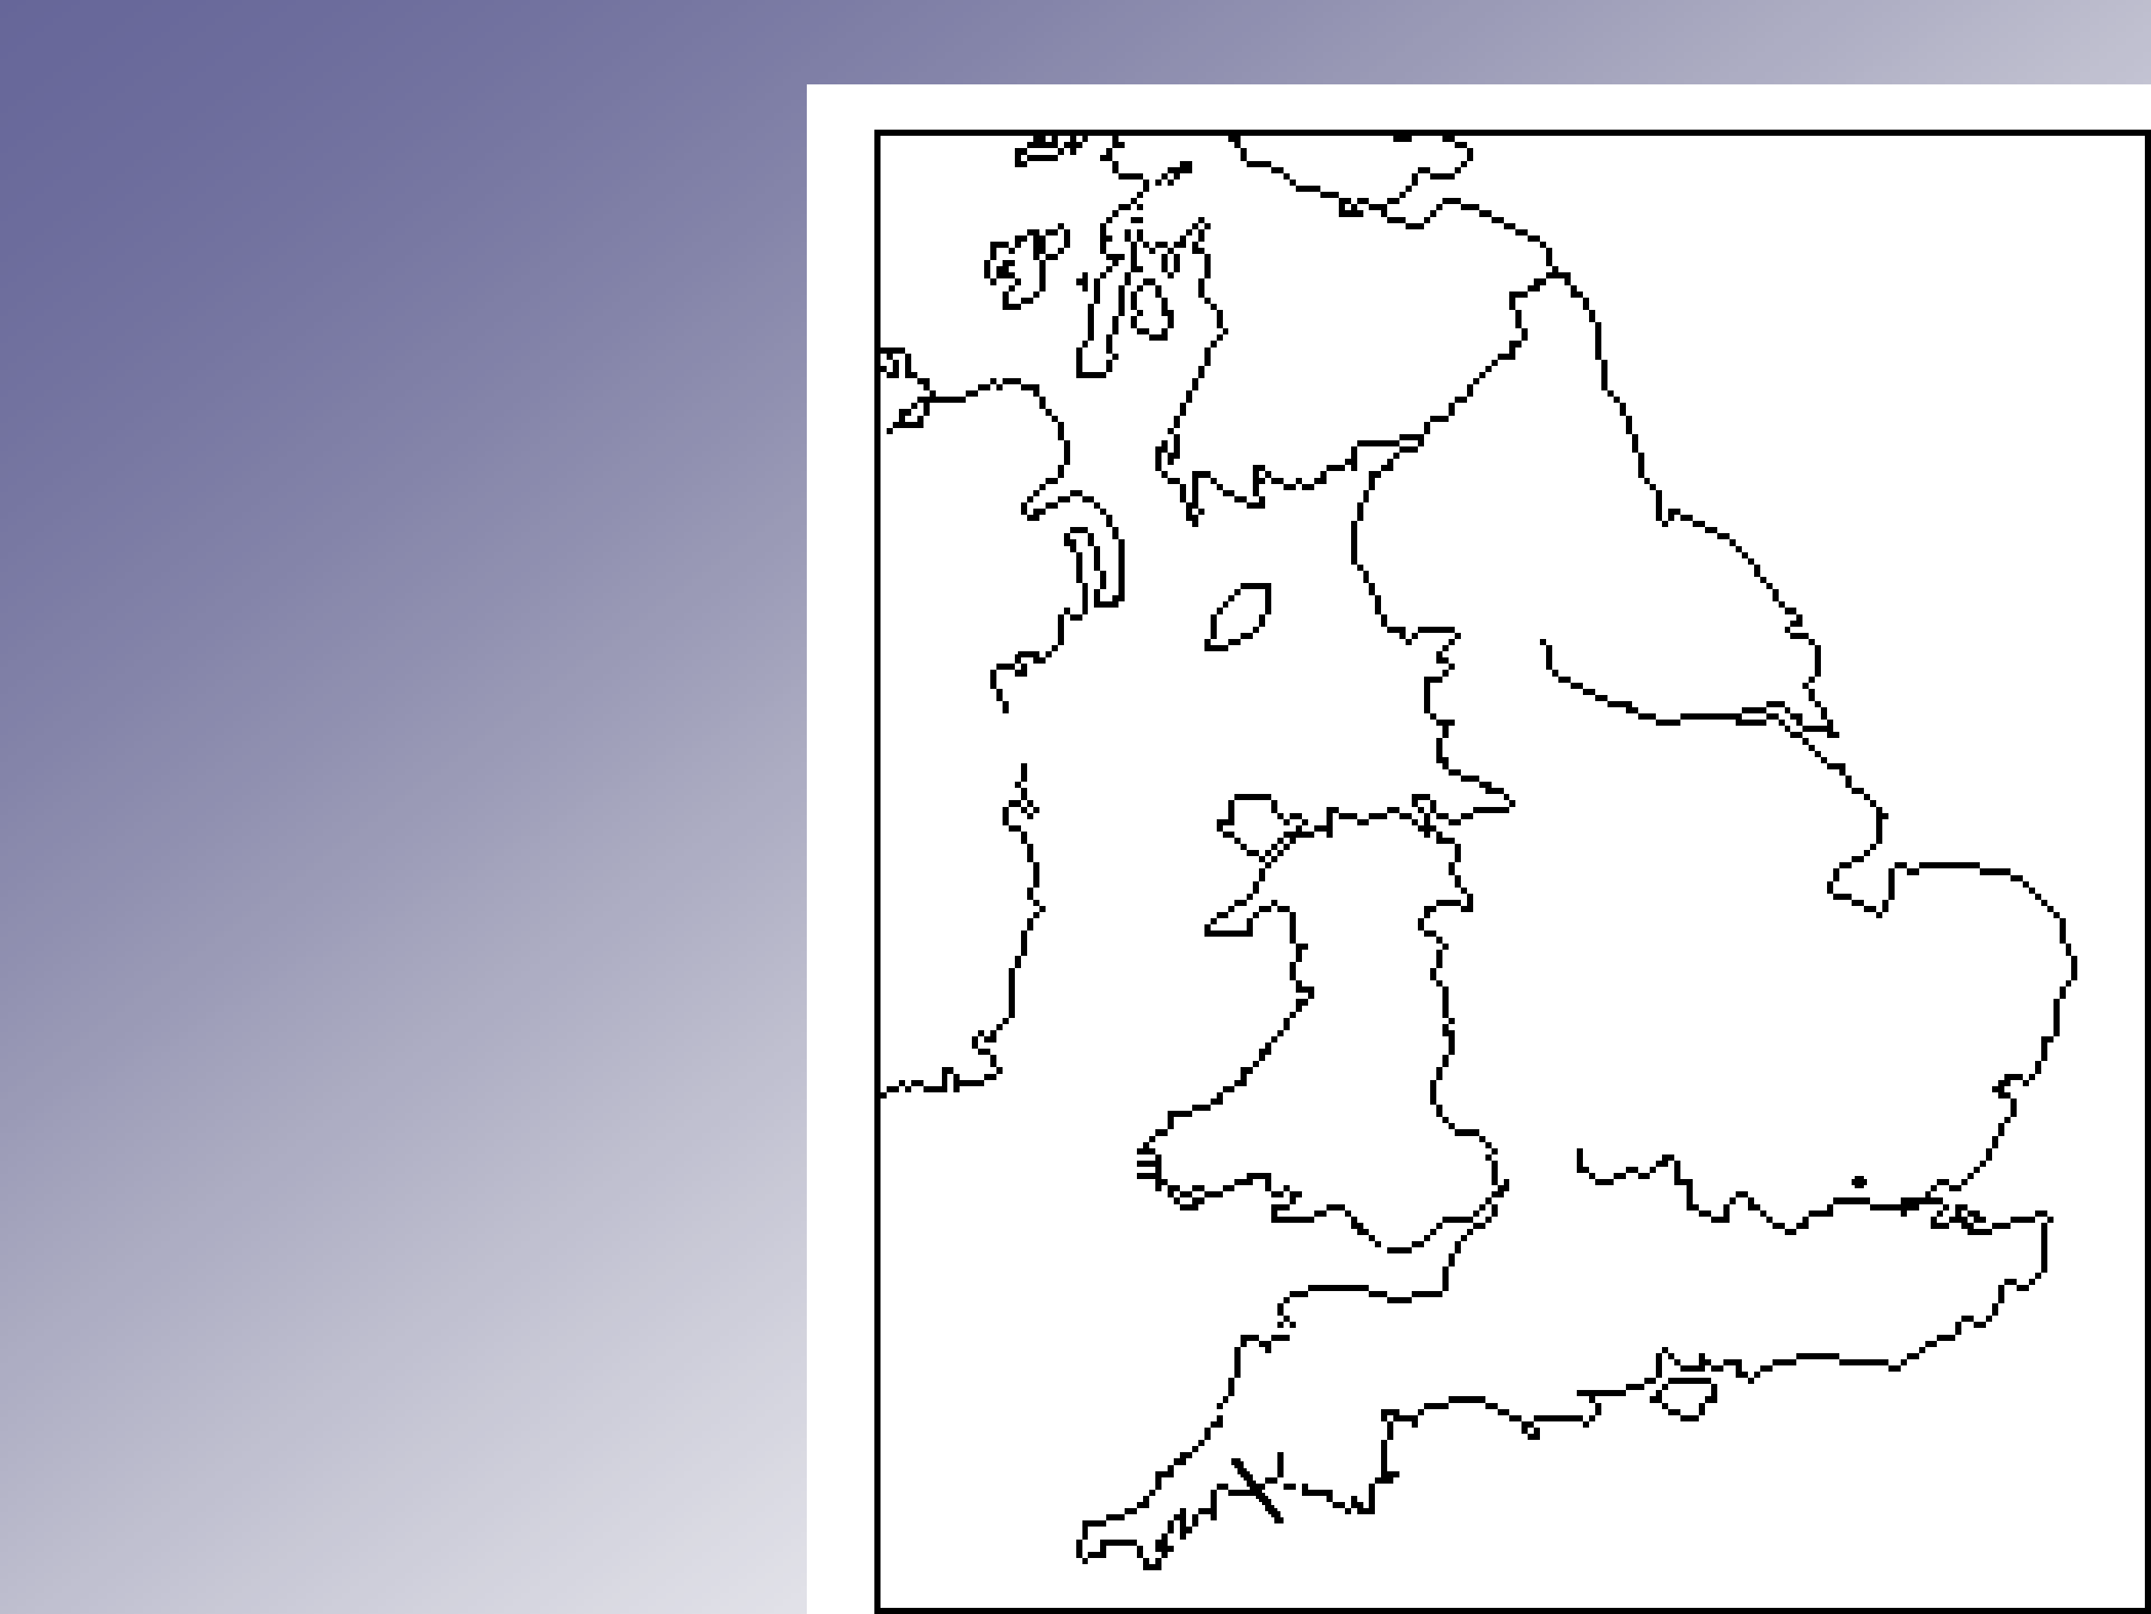
Lowland
ScOtS

MiddleEnglishdialectareas

Ireland

Wales

Cornwall

Northern

West Midland

Southern

East Midland

Kent

The dialects of Middle English
ThedialectalpositionofMiddleEnglishisbasicallyacontinuationofthatofOldEnglish.ThemostimportantextralinguisticfactforthedevelopmentoftheMiddleEnglishdialectsisthatthecapitalofthecountrywasmovedfromWinchester(intheOldEnglishperiod)toLondonbyWilliamtheConquerorinhisattempttodiminishthepoliticalinfluenceofthenativeEnglish.

NORTHERN
ThisdialectisthecontinuationoftheNorthumbrianvariantofOldEnglish.NotethatbyMiddleEnglishtimesEnglishhadspreadto(Lowland)ScotlandandindeedledtoacertainliterarytraditiondevelopingthereattheendoftheMiddleEnglishperiodwhichhasbeencontinueduptothepresenttime(withcertainbreaks,admittedly).
Characteristics.Velarstopsareretained(i.e.notpalatalised)ascanbeseeninwordpairslikerigg/ridge;kirk/church.

The dialects of Middle English

KENTISH
ThisisthemostdirectcontinuationofanOldEnglishdialectandhasmoreorlessthesamegeographicaldistribution.
Characteristics.ThetwomostnotablefeaturesofKentishare(1)theexistenceof/e:/forMiddleEnglish/i:/and(2)so-called"initialsoftening"whichcausedfricativesinword-initialpositiontobepronouncedvoicedasinvat,vaneandvixen(femalefox).

SOUTHERN
WestSaxonistheforerunnerofthisdialectofMiddleEnglish.NotethattheareacoveredintheMiddleEnglishperiodisgreaterthanintheOldEnglishperiodasinroadsweremadeintoCeltic-speakingCornwall.ThisareabecomeslinguisticallyuninterestingintheMiddleEnglishperiod.ItsharessomefeaturesofbothKentishandWestMidlanddialects.

The dialects of Middle English

WESTMIDLAND
ThisisthemostconservativeofthedialectareasintheMiddleEnglishperiodandisfairlywell-documentedinliteraryworks.ItisthewesternhalfoftheOldEnglishdialectareaMercia.
Characteristics. The retention of the Old English rounded vowels
/y:/and/ø:/whichintheEasthadbeenunroundedto/i:/and/e:/respectively.

EASTMIDLAND
Thisisthedialectoutofwhichthelaterstandarddeveloped.TobeprecisethestandardaroseoutoftheLondondialectofthelateMiddleEnglishperiod.NotethattheLondondialectnaturallydevelopedintowhatiscalledCockneytodaywhilethestandardbecamelessandlesscharacteristicofacertainareaandfinally(afterthe19thcentury)becamethesociolectwhichistermedReceivedPronunciation.
Characteristics. In general those of the late embryonic Middle
English standard.

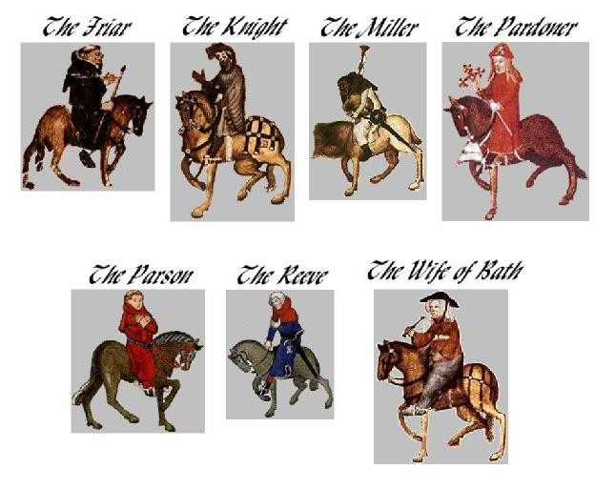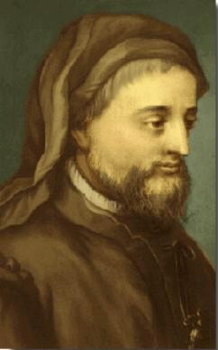Some figures from Chaucer‘s Canterbury Tales

Geoffrey Chaucer (1340-1399)

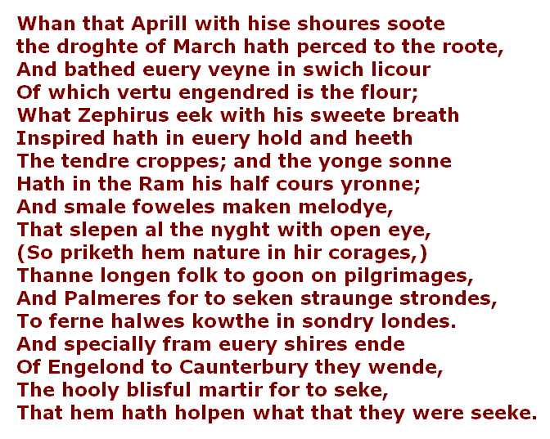
The opening lines of the Canterbury Tales by Geoffrey Chaucer read by an actor in an accent which is assumed to be that used at Chaucer‘s time (late 14th cCelnictukroyn).speaker symbol to listen to reading.

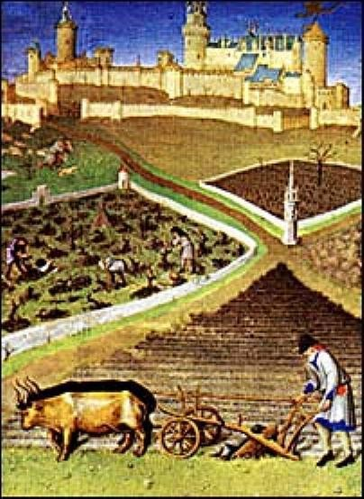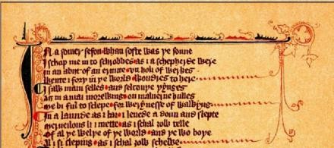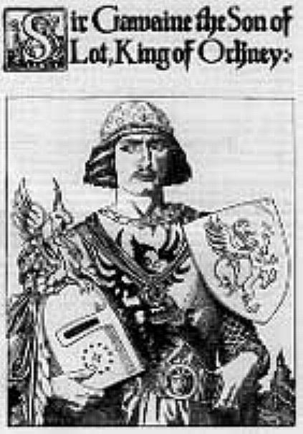

Sir Gawain and the Green Knight Piers Plowman

Click to listen:

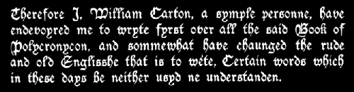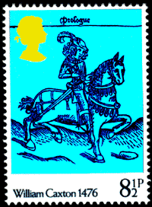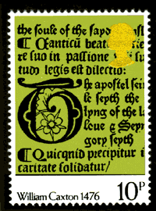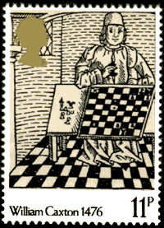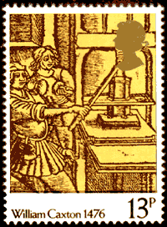

The introduction of printing

Printing was introduced to England in 1476 by William Caxton. This led to an increasing regularization of orthography and morphology.

English monarchs

  - West Saxon Kings

► | 802-839 | Egbert | 924-939 | Athelstan
► | 839-858 | Æthelwulf | 939-946 | Edmund
► | 858-860 | Æthelbald | 946-955 | Edred
► | 860-865 | Ethelbert | 955-959 | Edwy
► | 866-871 | Æthelred | 959-975 | Edgar
► | 871-899 | Alfred | 975-978 | Edward (the Martyr)
►  ► | 899-924 | Edward (the Elder) | 978-1016 | Æthelred (the Unready) Edmund (Iron side)
► | Danish Kings
► | 1016-1035 | Cnut (Canute) | 1040-1042 | Harthacnut
► | 1035-1037 | Harold (Regent) | 1042-1066 | Edward (the Confessor)
► | 1037-1040 | Harold I (Harefoot) | 1066 | Harold II

English monarchs (continued)

- NormanKings
- 1066-1087 |  | William I | 1087-1100 | William II (Rufus)
► |  | (the Conqueror) | 1100-1135 | Henry I
- House of Blois
- 1135-1154 |  | Stephen
- House of Plantagenet
► | 1154-1189 | Henry II | 1272-1307 | Edward I
► | 1189-1199 | Richard I | 1307-1327 | Edward II (Coeur de Lion)
► | 1199-1215 | John | 1327-1377 | Edward III
► | 1216-1272 | Henry III | 1377-1399 | Richard II
- House of Lancaster
► | 1399-1413 | Henry IV | 1413-1422 | Henry V
► | 1422-1461 | Henry VI

English monarchs (continued)

  - House of York

  - 1461-1470 Edward IV

- House of Lancaster
- 1470-1471 Henry VI
- House of York
- 1471-1483 Edward IV  - 1483-1485 Richard III | 1483 | Edward V
- House of Tudor
- 1485-1509 Henry VII | 1547-1553 |  | Edward VI
- 1509-1547 Henry VIII  - 1558-1603 Elizabeth I | 1553-1558 |  | Mary I
- House of Stuart

  - 1603-1625 James I (James VI of Scotland)
  - 1625-1649 Charles I

English monarchs (continued)
  - Commonwealth and Protectorate

- 1649-1653 Council of State1653-1658 |  | Oliver Cromwell
► | 1658-1659 | Richard Cromwell

  - House of Stuart(restored)

► | 1660-1685 | Charles II | 1689-1694 | William III (with Mary II)
► | 1685-1688 | James II | 1694-1702 | William III (alone)
► |  |  | 1702-1714 | Anne

  - House of Hanover

► | 1714-1727 | George I | 1820-1830 | George IV
► | 1727-1760 | George II | 1830-1837 | William IV
► | 1760-1820 | George III | 1837-1901 | Victoria

English monarchs(continued)

  - House of Saxe-Coburg

  - 1901-1910 Edward VII

  - House of Windsor

- 1910-1936 | George V | 1936-1952 | George VI
- 1936 | Edward VIII | 1952- | Elizabeth II

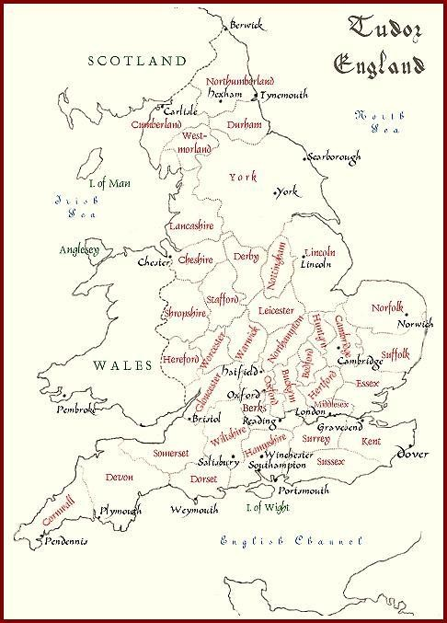

Tudor England(16th

century)

The Great Vowel Shift

ThemajorchangetoaffectthesoundsystemofMiddleEnglishisthatwhichresultedinare-alignmentofthesystemoflongvowelsanddiphthongswhichistraditionallyknownastheGreatVowelShift.Essentiallylongvowelsareraisedonelevelandthetwohighvowelsarediphthongised.TheshifttookseveralcenturiestocompleteandisstillcontinuinginCockney(popularLondonspeech).Theshiftofshort/u/toalowervowelasinpresent-daysouthernEnglishbut,whichbeganinthemid17thcentury,isnotpartofthevowelshift.

Great Vowel Shift

(1300) | 1400 |  | 1500 | 1600 | 1700 | 1800 | present
drfi'en | /i:/ | /Ii/ | /ei/ | /ei/ | /zi/ | /ai/
hoase | /u:/ | /uu/ | /ou/ | /su/ | /xu/ | /au/
feet | /e:/ |  | /i:/
fool | /o:/ |  | /u:/
beat  foal | /z:/  /n:/ |  |  |  | /e:/  /O:/ | /i:/ | /au/
i‹ake | /x/ |  | /:e:/ | /e:/ | /e:/ | /eF
sail | /ai/ |  | /:ei/ | /ci/ | /e:/ | /ei/
Jmr | /au/ |  | /ou/ | /o:/

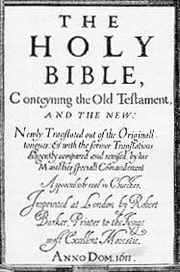

Title page of the Authorized Version of the Bible, these-called King James Bible(1611)

Dialects of English

The dialects of present-day English can be seen as the continuation of the dialect areas which established themselves in the Old English period. The dialectal division of the narrower region of England into 1) a northern, 2) a central and 3) a (subdivided) southern region has been retained to the present-day. The linguistic study of the dialects of English goes back to the 19th century when, as an off spin of Indo-European studies, research into (rural) dialects of the major European languages was considerably developed. The first prominent figure in English dialectology is Alexander Ellis (mid-19th century), followed somewhat later by Joseph Wright (late 19th and early 20th century). The former published a study of English dialects and the latter a still used grammar of English dialects at the beginning of the present century. It was not until the Survey of English Dialects, first under the auspices of Eugen Dieth and later of Harald Orton, that such intensive study of (rural) dialects was carried out (the results appeared in a series of publications in the 1950's and 1960's).

Dialects of English(continued)

Dialect features
The main divide between north and south can be drawn by using the pronunciation of the word but. Either it has a /u/ sound (in the north) or the lowered and unrounded realization typical of Received Pronunciation in the centre and south. An additional isogloss is the use of a dark /l/ in the south versus a clear /l/ in the north. The south can be divided by the use of syllable-final /r/ which is to be found in the south western dialects but not in those of the south east. The latter show 'initial softening' as in single, father, think with the voicedinitial sounds /z-, v-, 'eth'/respectively.

NORTH

NORTHERN

LQ

liñ. rh
fl

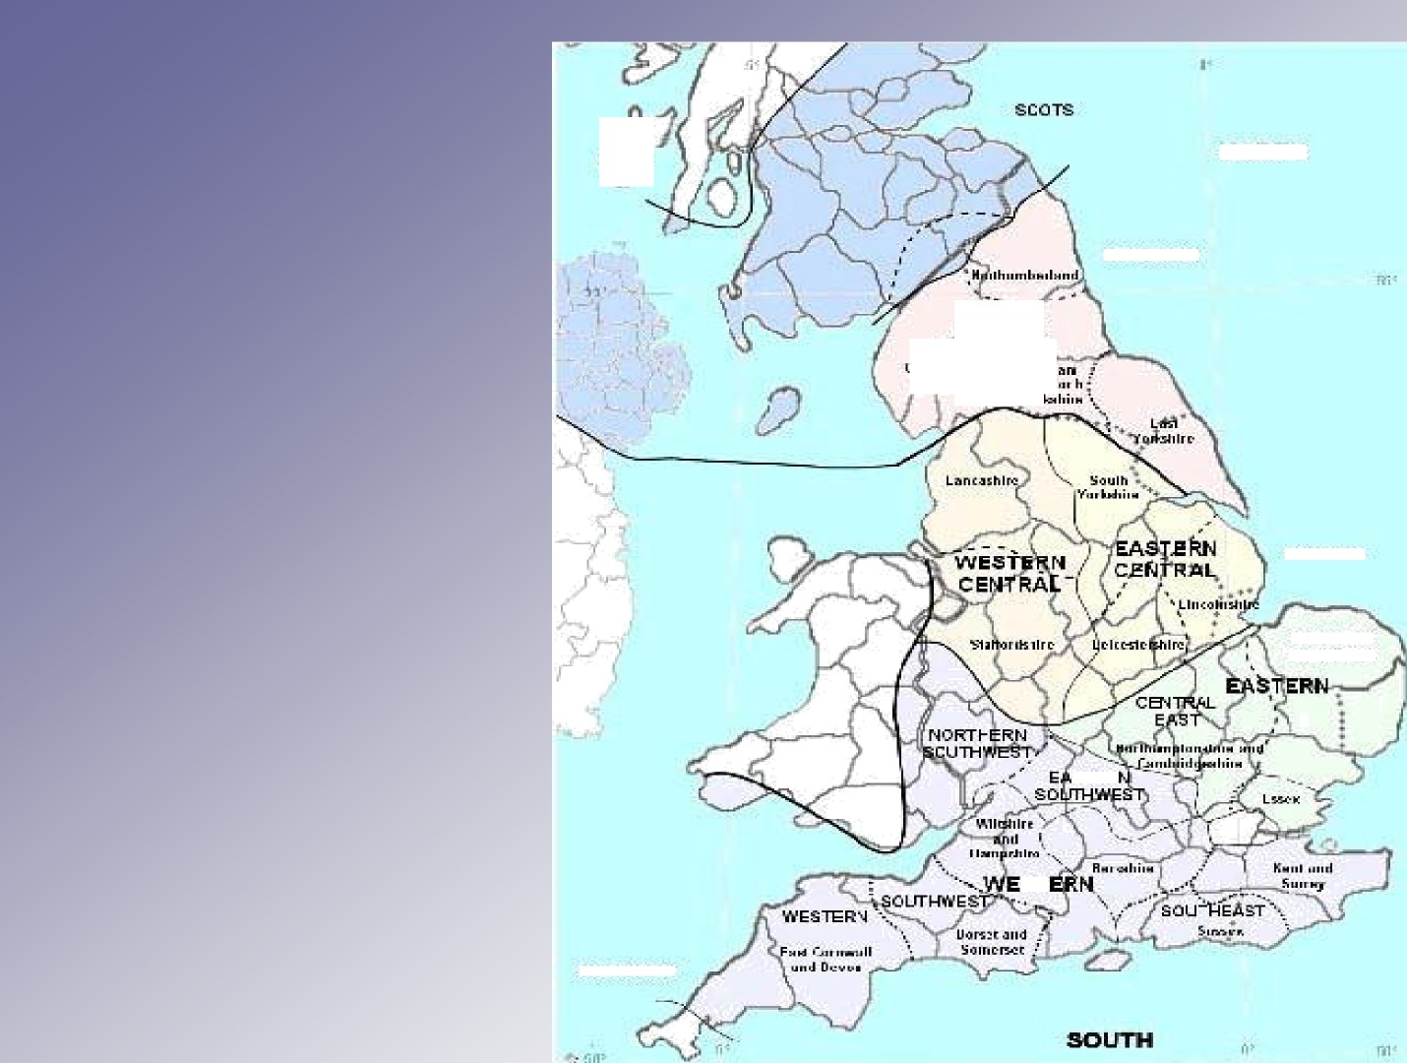English dialects

(traditional)
' - YoI

CENTRAL

EASTERN CDMfJTlG6

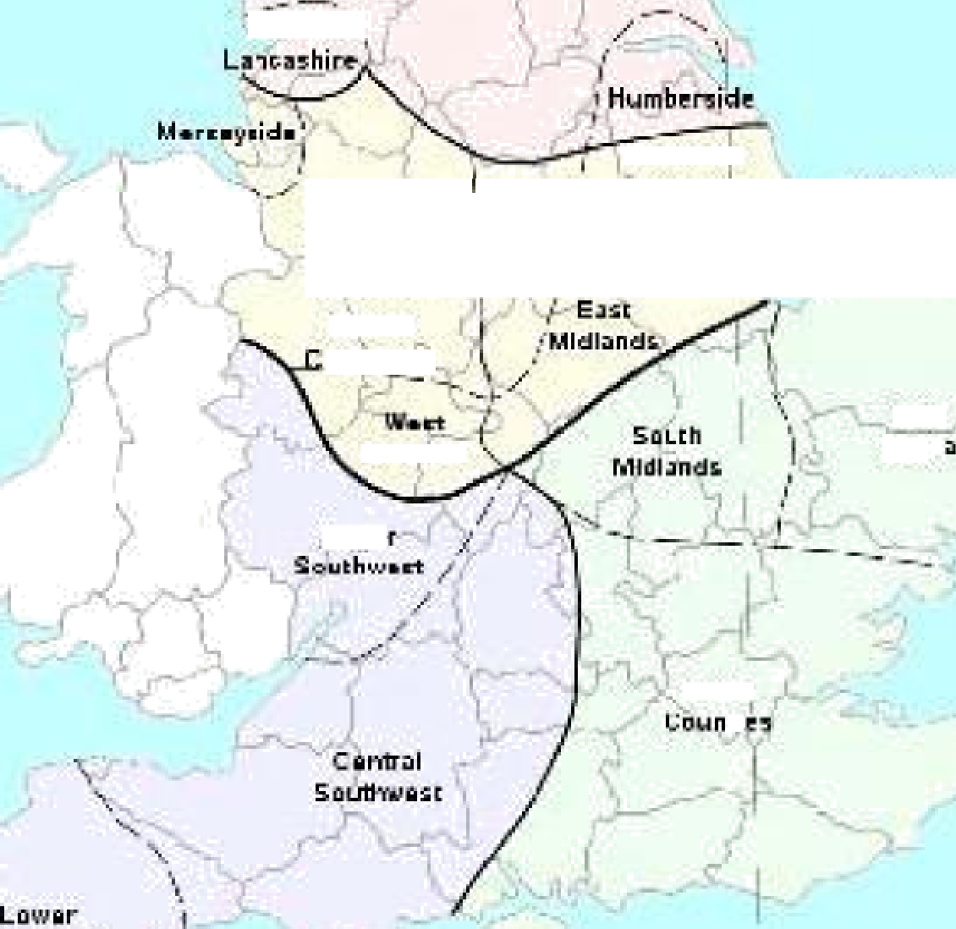English dialects
i
Mld ailds
EAST
CENTRAL
Mldland3
Ease
°"S**
uPrc
EAST

(contemporary)

', NORTHEAST

LDwER
NORTH
NORTH

NORTHERN

8OUTHWE9T

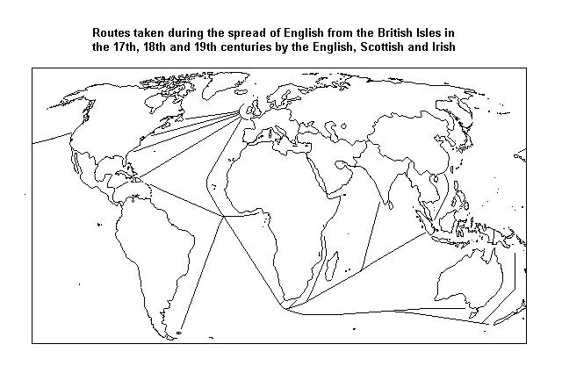Spread of English in colonial period

English in the world today

Be M/@T@I@MdS Gibraltar Bahamas
TurkS and Caicos 1s.
W.estI.ndie.s

UAL

Blrma

Hong gong

jamaica

Bahamas n’dzdand
Tobago

Sierracone

St. Helena TristandaCunha

Republlc

zan

azlland who

Seychelles

ChagosIsland
Isa Sri 2imbabnc
gt ThePhi|ippiftgs aysia

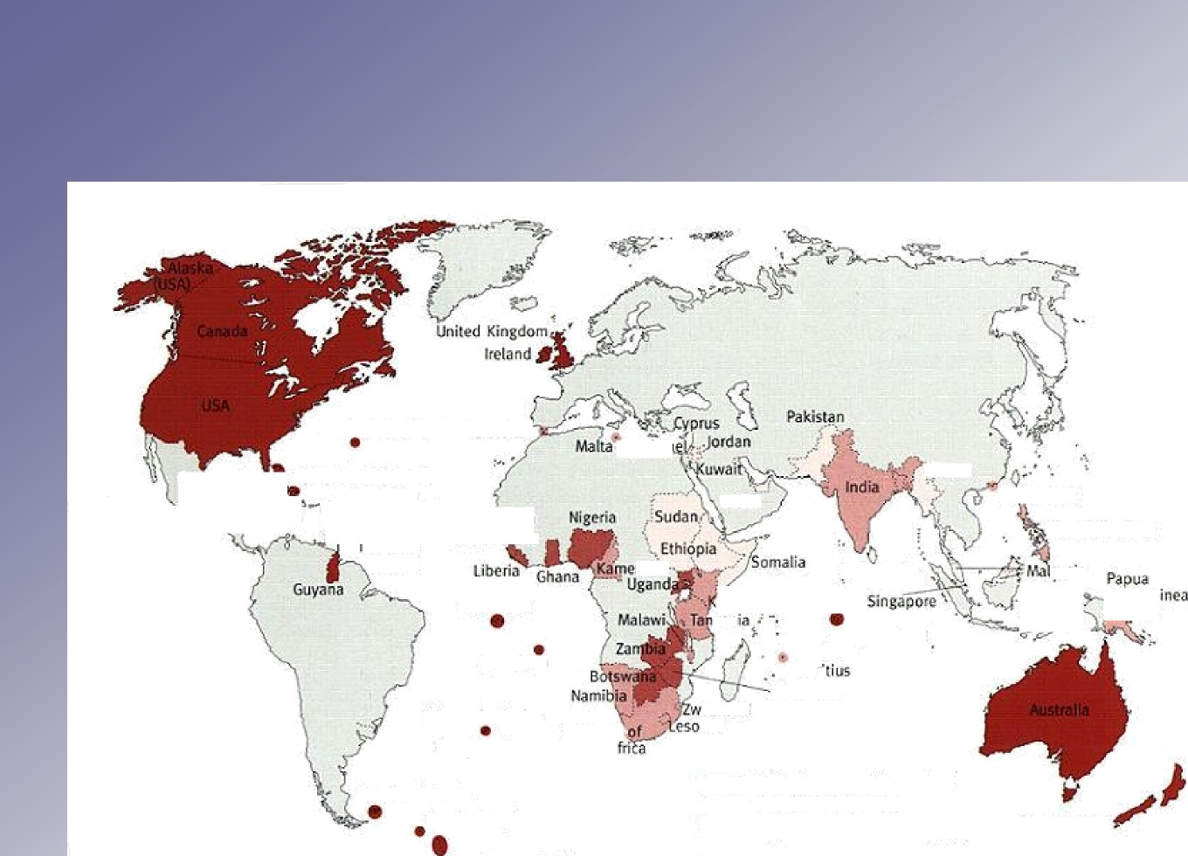toughIs. SouthA

FaiMand TSJand3
Soulh Georgia

3outh Sandwich Islands

Native language of more than 45% of the population
Englishassoleofficiallanguage ’ 4'"” d English as second officiallanguage
English as semi-official language

Recommended literature

Barber, Charles, Joan C. Beal and Philip A. Shaw 2009. The English language. A historical introduction. Second edition of Barber (1993). Cambridge: University Press.

Baugh, Albert C. and Thomas Cable 1993 A history of the English language. 4th edition. (Englewood Cliffs: Prentice Hall).

Crystal, David 1995. The Cambridge encyclopedia of the English language. Cambridge: University Press

Crystal, David 2004. The Stories of English. Harmonds worth: Penguin.
Fennell, Barbara 1998. A history of English. A sociolinguistic approach. Oxford: Blackwell. Hogg, Richard M. and David Denison (ed.) 2006. A history of the English language.
Cambridge: University Press.

Muggle stone, Lynda (ed.) 2006. The Oxford History of English. Oxford: University Press.

Pyles, Thomas and John Algeo 1993. Origins and development of the English language. 4th edition. (New York: Harcourt, Brace, Jovanovich).

