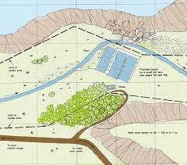PITHAPUR RAJAH’S GOVERNMENT COLLEGE KAKINADA 533 001-ANDHRA PRADESH
Dr. I. S. CHAKRAPANI
Assistant Professor, Department of Zoology
PRR & VS Govt. Degree College, Vidavalur
Nellore
M.Sc., Ph.D.
An AUTONOMOUS and NAAC Accredited Institution ₍ A Grade- 3.17 CGPA )
(Affiliated to ADI KAVI NANNAYA UNIVERSITY, Rajamahendravarm)

DEPARTMENT OF ZOOLOGY GUEST LECTURE
On 21.06.2021, at 3.00 PM , On Google Meet

ON

POND CONSTRUCTION

Lead Speaker

ORGANISED BY THE
DEPARTMENT OF ZOOLOGY & AQUACULTURE
PITHAPUR RAJAH’S GOVERNMENT COLLEGE (A), KAKINADA

